**Holi color powder throwing festival in India**

During the Holi festival, Indians throw colored powder at each other to represent the freedom and class distinction that exists in society.

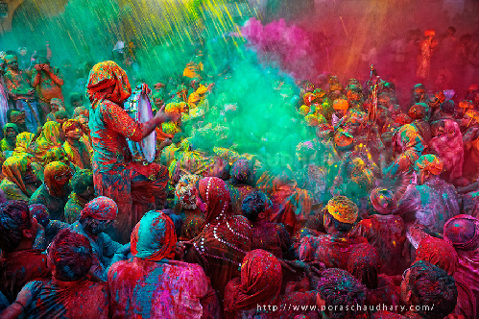

Holi festival, also known as 'Festival of Colors' held on the full moon day of Phalgun month is one of the major and important festivals of the Indian people.

Celebrated on the full moon day of the Hindu month of Phalgun, Holi also known as the 'Festival of Colors' is one of the important festivals of India, as well as many countries with communities. Hindus live.

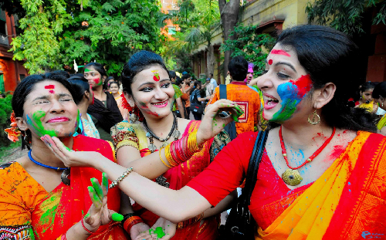

Holi marks the end of winter and the beginning of spring with the hope of a bountiful harvest. This festival also celebrates the victory of good over evil.

Holi festival marks the beginning of spring and celebrates the victory of good over evil.

Rituals and traditions during Holi

Holi is an ancient Hindi festival with many religious and cultural rituals.

Preparing for Holika's pyre

Days before the festival, people start collecting wood and flammable materials for campfires at parks, community centers, areas near temples and other open spaces. On the pyre is an effigy representing Holika, who tricked Prahalad into the fire. In the house, the women prepare to cook typical holiday dishes such as gujiya, mathri, malpuas as well as many other delicious dishes for the festival

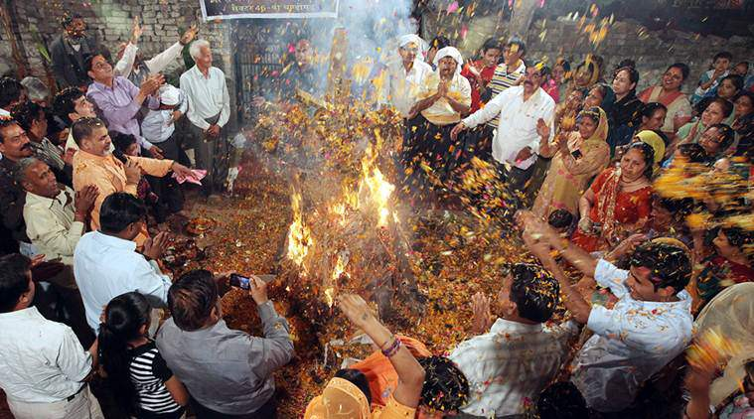

Holika Dahan

On the eve of the festival, usually just in time or after sunset, people gather together and light the pyre. This ritual is called Holika Dahan. The ritual symbolizes the victory of good over evil. Everyone sang and danced happily around the fire.

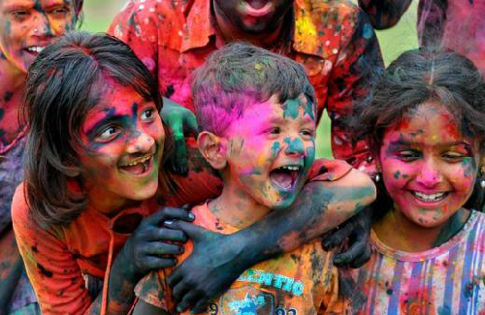

During Holi, people throw colored powder at each other, making everyone look like a colorful painting.

Have fun with colors

Holi is officially started the next morning and people play with colors. Everyone holds in their hands dry gouache or balls containing colored liquid to throw and spray color at others.

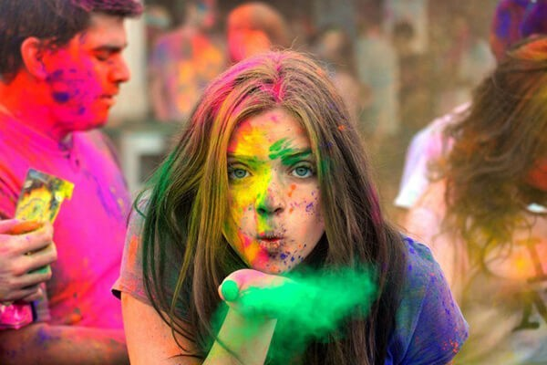

These colors are traditionally blended with natural botanicals that can be easily removed such as saffron, sandalwood and rose. People come together to take part in this exciting game. By the end of the morning, everyone looks like a colorful painting. And this is the reason why Holi is also known as the 'Festival of Colors'.

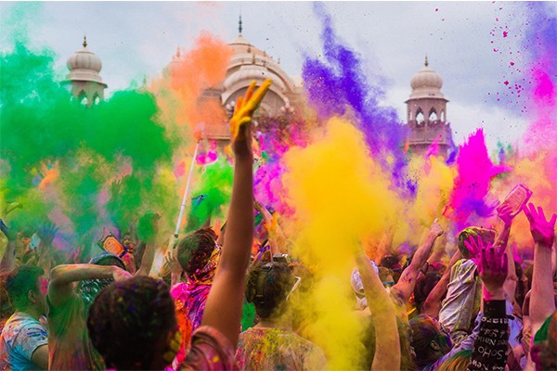

People gathered in groups singing and dancing while drumming and dholak. Every time the 'war' with colors is paused, everyone eats gujiya, mathri, malpuas and many other traditional dishes. Bhang, a beverage made from local herbs, is also an integral part of Holi.

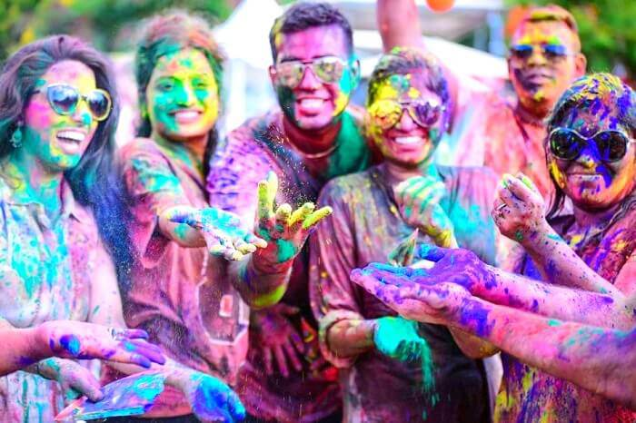

Other variations of the festival

In the Braj region near Mathura, in northern India, the festival can last for more than a week. Here, people not only have fun with colors but also have another special day, when the men go around with their shields and the women have the right to hit their shields. with sticks. In the south of India, people worship and make offerings to Kaamadeva, the god of love in Indian mythology on the occasion of the festival.

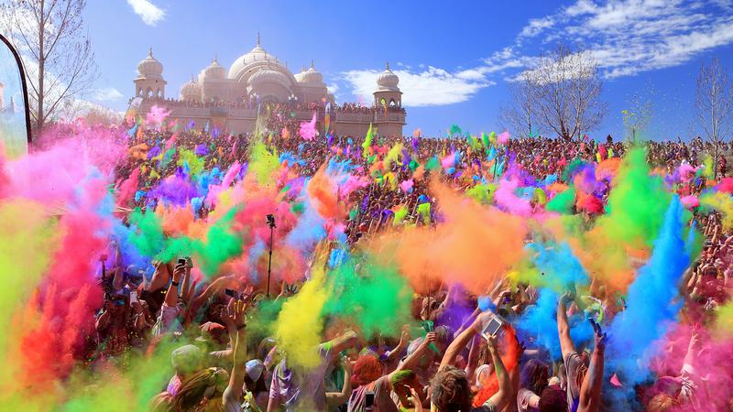

The end of the festival day

After a day playing with colors, everyone takes a bath to clean up and put on new costumes to welcome friends and relatives over. Holi is also a festival of forgiveness and the beginning of a new beginning, with the aim of creating harmony in society, leaving behind all hatred.

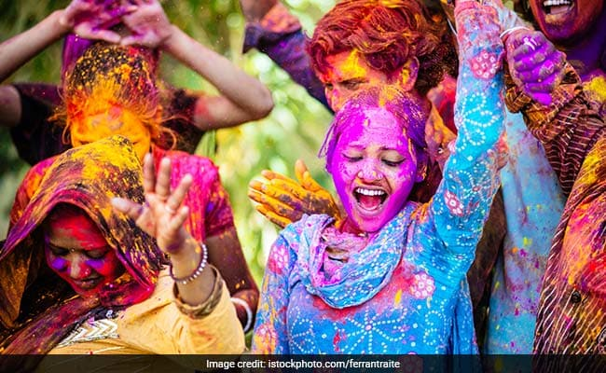

On this day, all hatred is left behind, all men, young and old, join together in the atmosphere of the festival.

Festival Time

Holi festival is held on the full moon day in March every year. This year, Holi festival will be held on March 17. However, the festival is also celebrated a day earlier in some parts of eastern India, such as West Bengal.

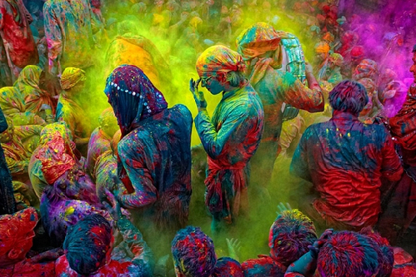

Festival venue

The Colorful Festival is celebrated almost everywhere in India. The biggest festival is held in Mathura, about 4 hours from Delhi.